Assignment 1

Name: Suryansh Sandeep Kumar Singh

Div.: B

Roll No: S1951122

PRN: 72018560C

Problem Statement: -

Write a program to implement Fractional knapsack using Greedy algorithm and 0/1 knapsack using dynamic programming. Show that Greedy strategy does not necessarily yield an optimal solution over a dynamic programming approach.

1. Fractional knapsack using Greedy algorithm

Code:

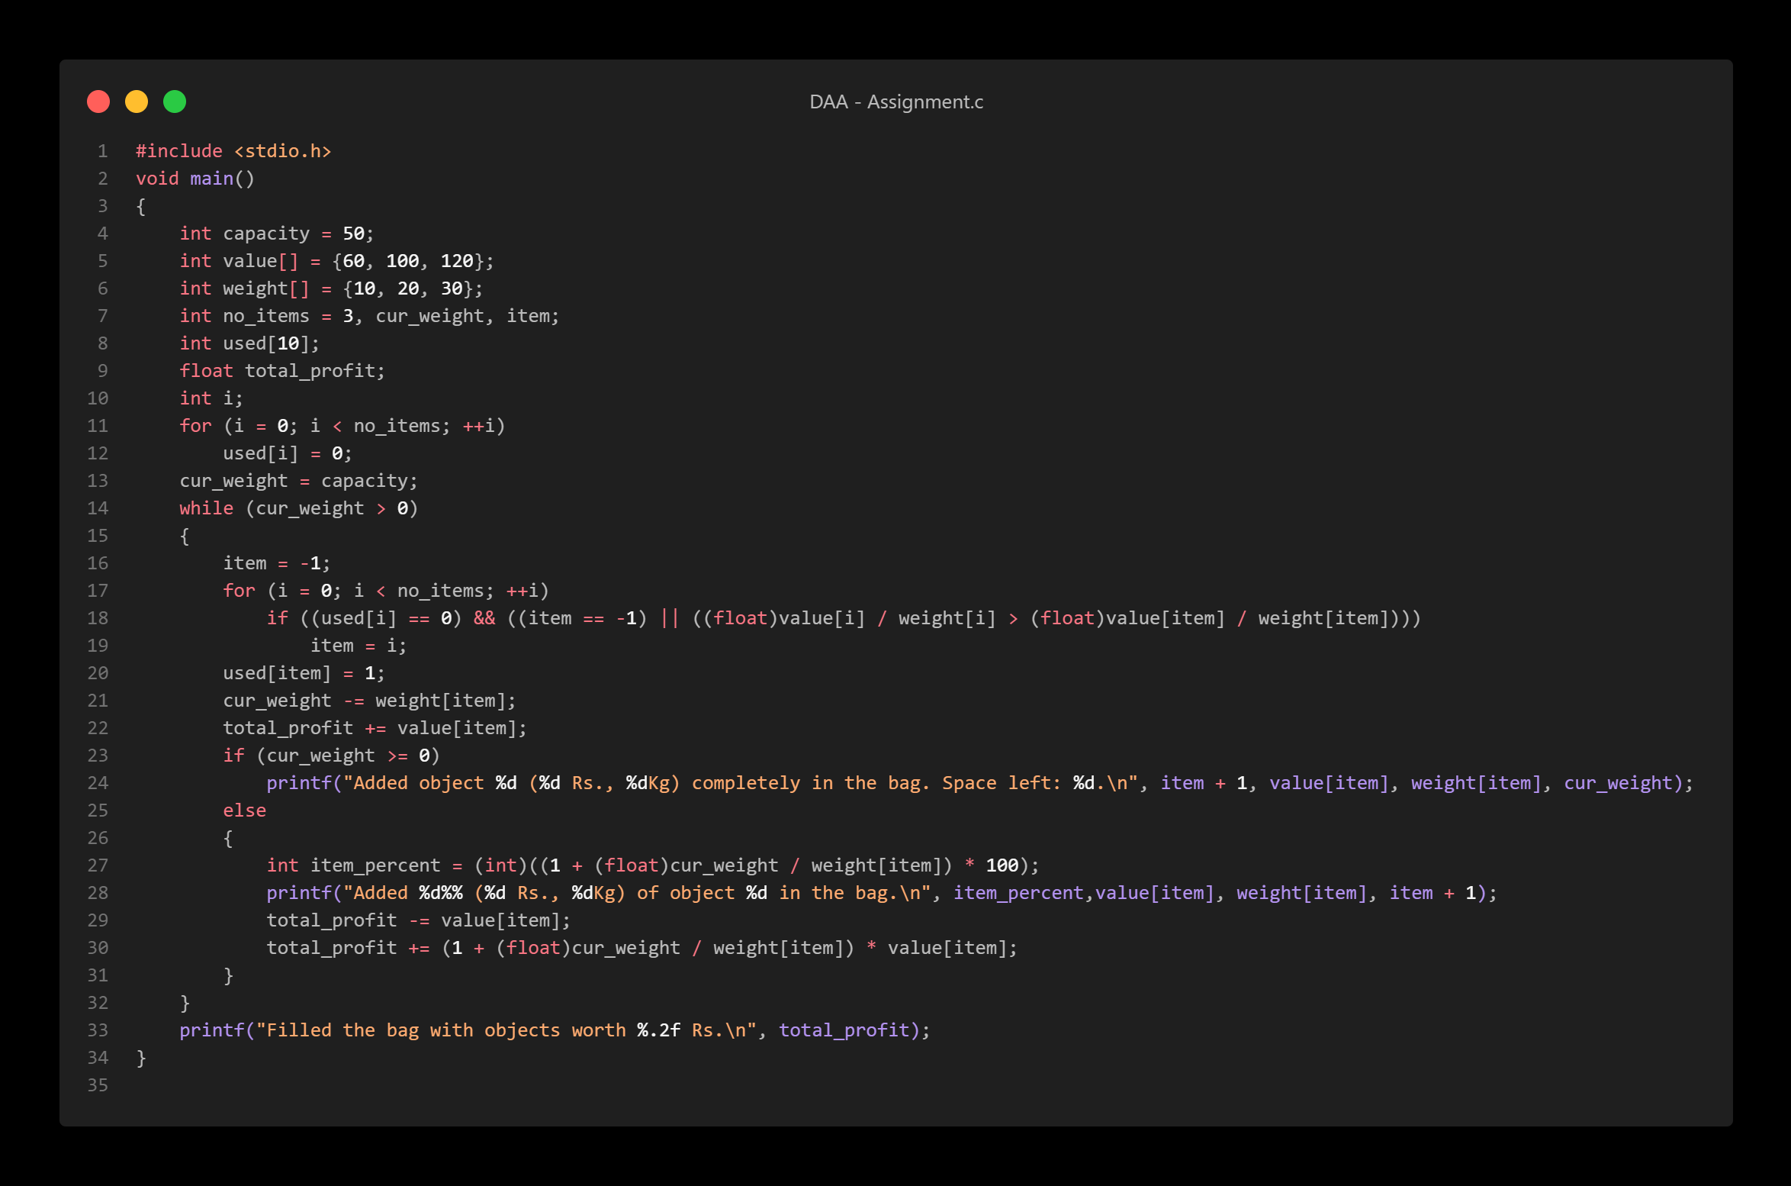

Output:

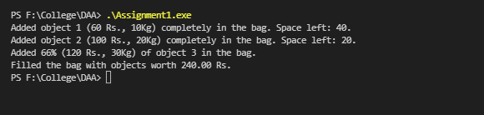

2) 0/1 knapsack using dynamic programming

Code:

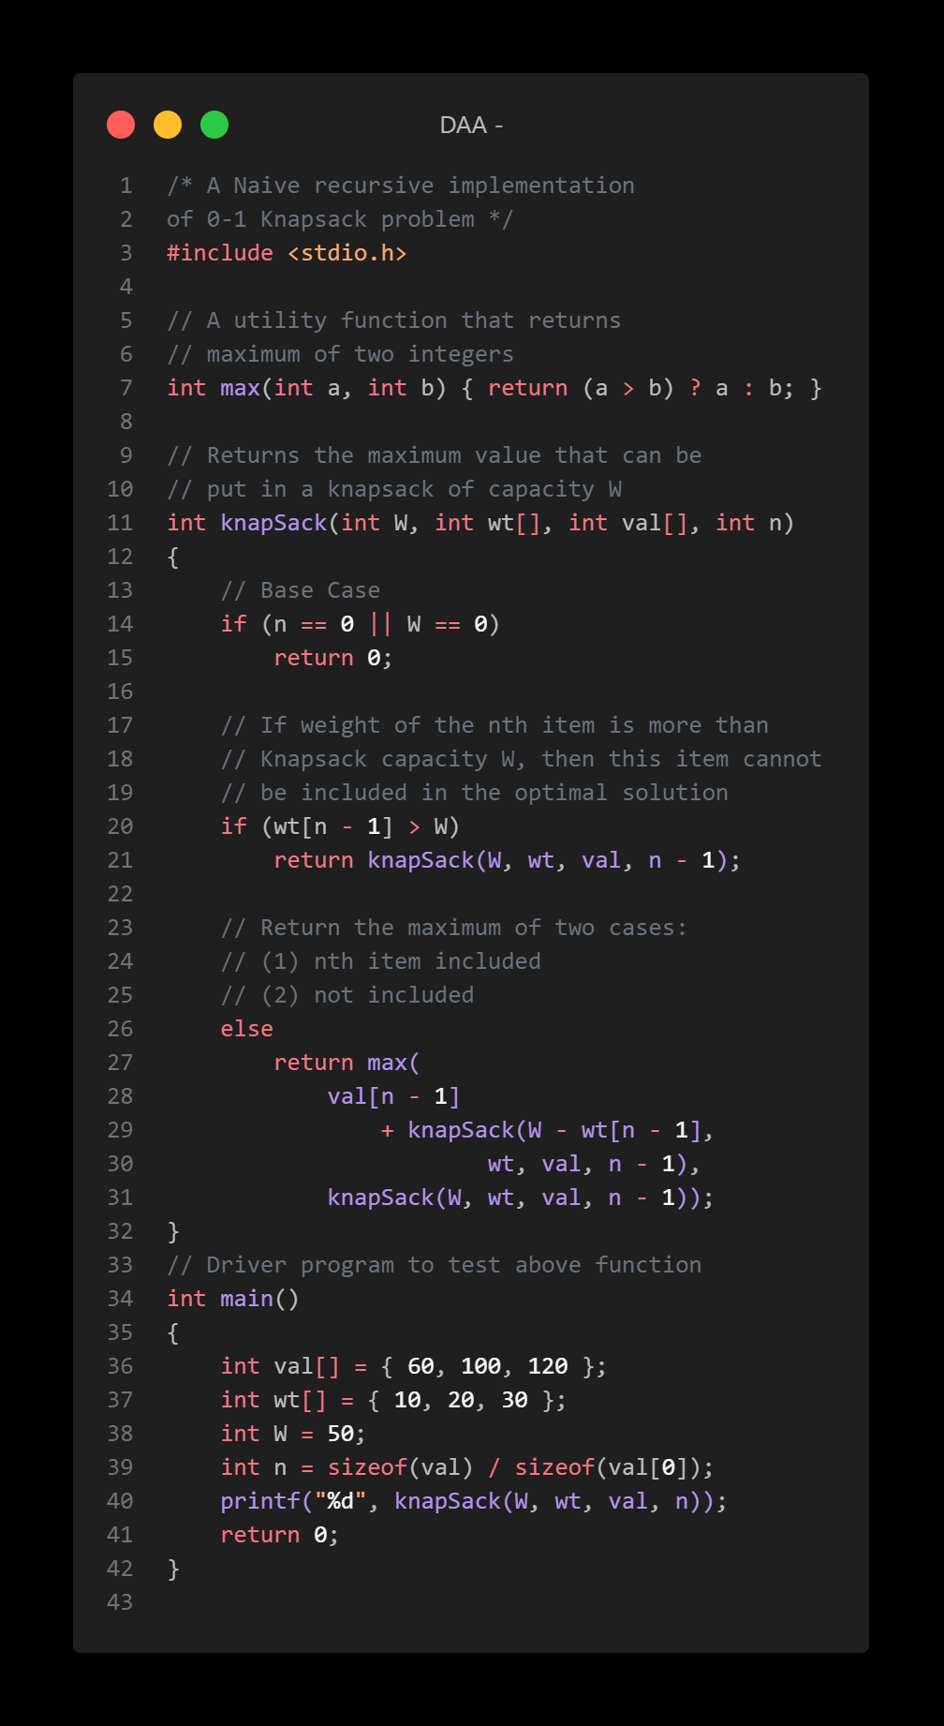

Output:

